Problems in Asset management system
- In “Asset Receive / Transfer”, Purchase entry date is not showing when transferring. (Closed) Reported to Jakia.

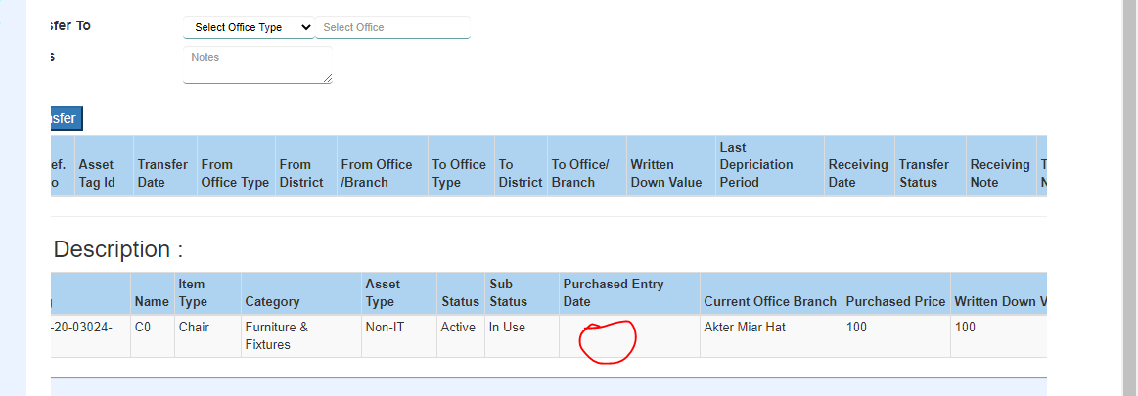

- In “Asset Entry” UI confluence, User cannot put the images when creating asset. User can put the images after creating asset by update operation. But how? (Open)

- Mis-match found in “Fixed Asset Register Report” after doing transactions both in “Branch System” and “Online System”.

- An "Asset 0" is entered from "Branch 1" selecting Physical Location "Branch 2". Now the purchase transaction and journal are showing in "Branch 2". Is it ok?

- In Online system "Asset Register Report" => "Depreciation Opening Balance", "Depreciation During Year", "Depreciation Adjusted", "Depreciation Closing Balance" is not following "Branch System" and also as per confluence rules.

- In Online system "Asset Register Report" is not following "Confluence" and "Branch System" properly.

- In "Branch System", Sold item is shown in "Fixed Asset Register" of creation Branch. But in Online it is showing in Location Branch. Also, there is nothing written in confluence about it.

- An item in purchased on June 25, 2019 then depreciation calculated on June 13, 2020 after that transferred from one branch to another on June 13, 2020. Now the asset is received by another branch on June 13,2020 but another branch could not be able to get the asset in “On Demand Asset Depreciation” list to perform depreciation. (Pending)

Questions

- In “Asset Transaction”, Why for “Transaction Id” column 1st digit value is 6.

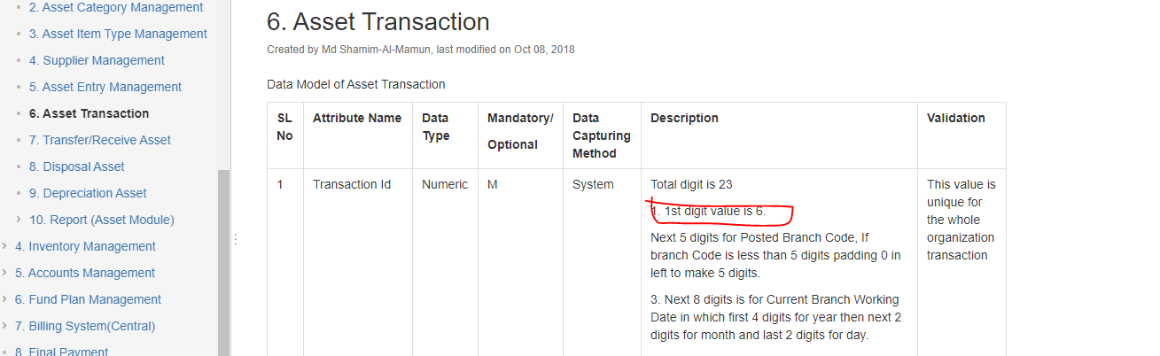

- Some field are missing in “Supplier”. E.g. Vendor. UI mismatch.

- Also, in “Supplier” where is the settings.

Vat and Tax category is already populated by selecting Item Type then why supplier?

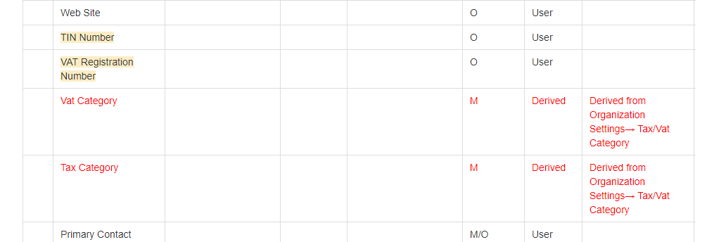

- Total value (100) should be equal to (Written Down value + Accumulated Depreciation) = (88 + 13)

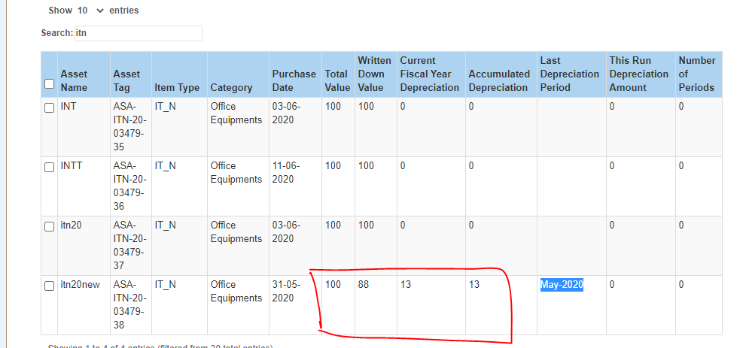

- In “Asset Depreciation”, “Transaction Date” is wrongly displaying?
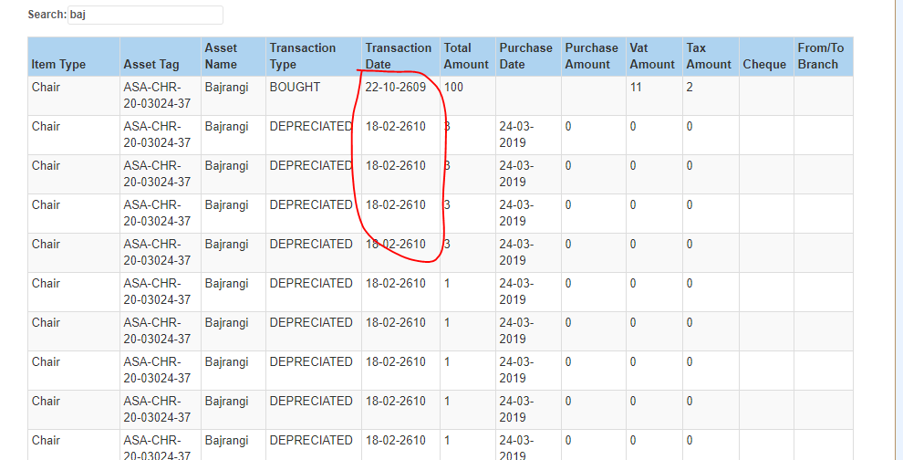

VAT and TAX slab

For Item 1 (Fiscal year wise): After fiscal year end, “Total Amount” and “Payment” should be 0.
Slab 1: Amount from 0tk. To 20 Lakh= 2%
Slab 2: Amount from 20 Lakh to above = 4%

Vendor Name | Amount | Total Amount | Apply Percentage | Calculation | Payment
Vendor 1 | 5 Lakh | 5 Lakh | 2% | (5 Lakh * 2%) = 10k | 10k
Vendor 1 | 5 Lakh | (5+5) = 10 Lakh | 2% | (5 Lakh * 2%) = 10k | (10k + 10k) = 20 k
Vendor 1 | 10 Lakh | (5+5+10) = 20 Lakh | 2% | (10 Lakh * 2%) = 20k | (10k + 10k+ 20k) = 40k
Vendor 1 | 3 Lakh | (5+5+ 10 + 3) = 23 Lakh | 4% (Because cross the slab of total 20Lakh = (5 + 5 + 10) | (23 Lakh * 4%) = 92k | 92k – (10k + 10k + 20k) = (92k – 40k)  = 52k (because slab change and calculation should be changed. Calculation should be using 4% by deduction previous calculated amount.
Vendor 2 | 5 Lakh | 5 Lakh | 2% (Because new vendor) | (5 Lakh * 2%) = 10k | 10k
Vendor 2 | 5 Lakh | (5+5) = 10 Lakh | 2% | (5 Lakh * 2%) = 10k | (10k + 10k) = 20 k

Report Problems

- Title: (Closed) Reported in Jira AMMSW-2592
In “Fixed Asset Register” report, in Branch system data showing in “Item Location” column. But in Online system there is no data showing in “Location” column for migrated data.
Description:
In “Fixed Asset Register” report, in Branch system data showing in “Item Location” column. But in Online system there is no data showing in “Location” column for migrated data.
References:
- Branch Info: Pirojpur => Bagerhat => Bagerhat Sadar => Polerhat (1136)

Screenshot:
Please see details in screenshot
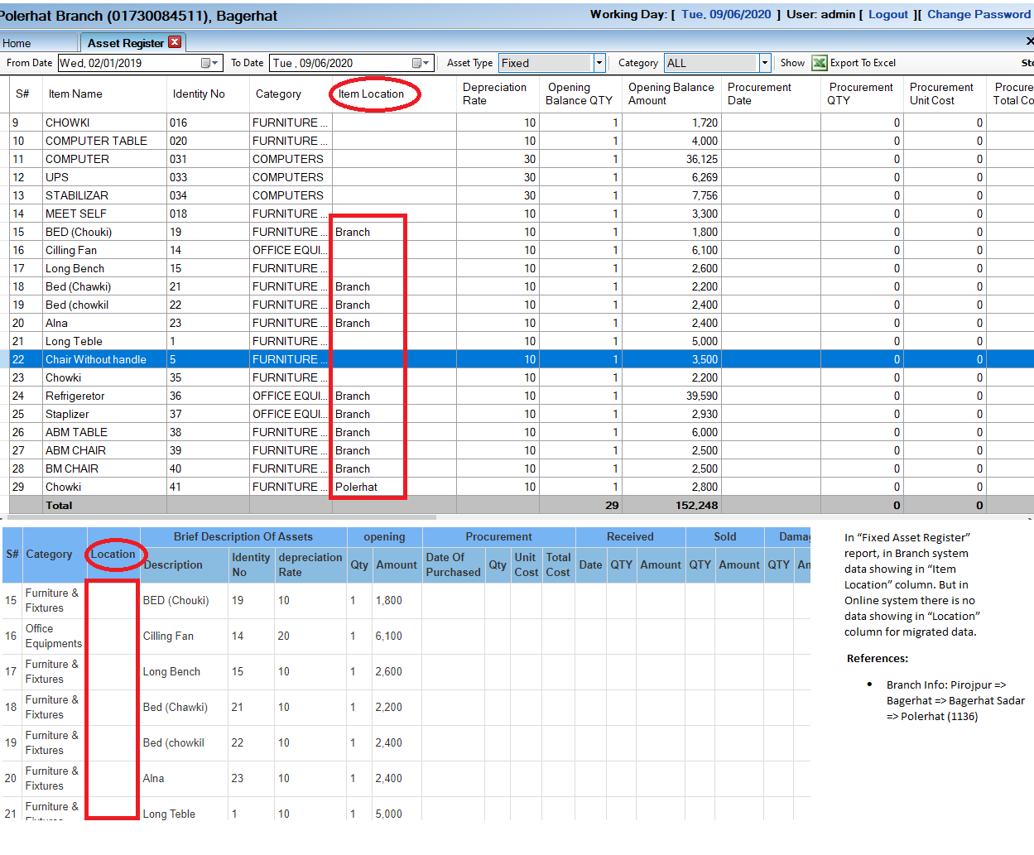
- Title: (Closed) for newly bought item, “Purchase Date”, “Purchase Amount” should be empty. “Purchase Date” and “Purchase Amount” should be shown when there is transfer/receive of an Asset.

In “Asset Transaction” UI, “Purchase Date” and “Purchase Amount” is blank for bought item.

Description:
In “Asset Transaction” UI, “Purchase Date” and “Purchase Amount” is blank for bought item.

References:
- Branch Info: Pirojpur => Bagerhat => Bagerhat Sadar => Polerhat (1136)

Screenshot:
Please see details in screenshot

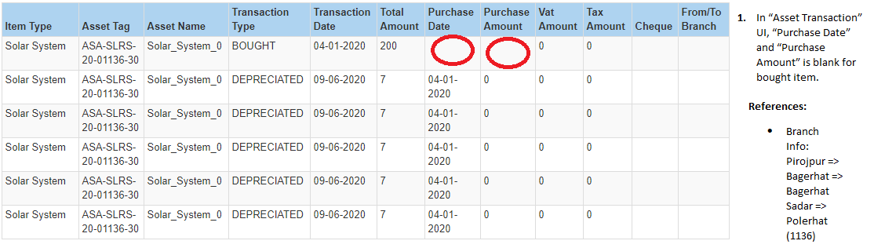

- Title: (Closed) Ignore it.
In “Confluence” it is written that “Fixed Asset Register” can be sort by Category, Item Type, Tag Id which is not implemented in Online system.

Description:
In “Confluence” it is written that “Fixed Asset Register” can be sort by Category, Item Type, Tag Id which is not implemented in Online system.
References:
- Branch Info: Pirojpur => Bagerhat => Bagerhat Sadar => Polerhat (1136)

Screenshot:
Please see details in screenshot
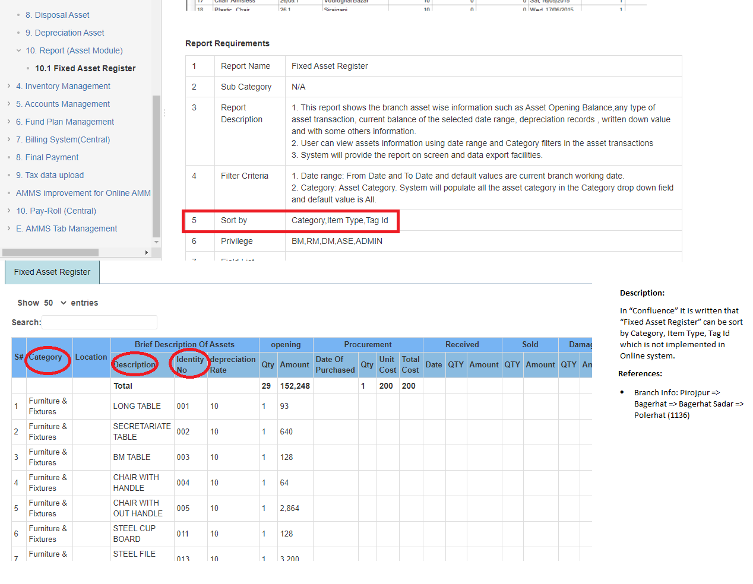

- Title: (Closed) Already talked to Moinul, Asiful, Dastogir. It was happening because report was calculating depreciation based on “TransactionDate”. Depreciation should be calculated based on “DepreciationPeriod”.
In Online system "Fixed Asset Register Report" => "Depreciation Opening Balance", "Depreciation During Year", "Depreciation Adjusted", "Depreciation Closing Balance" is not showing values as per "Branch System" and confluence rules.

Description:
In Online system "Fixed Asset Register Report" => "Depreciation Opening Balance", "Depreciation During Year", "Depreciation Adjusted", "Depreciation Closing Balance" is not showing values as per "Branch System" and confluence rules.

References:
- Branch Info: Pirojpur => Bagerhat => Bagerhat Sadar => Polerhat (1136)

Screenshot:
Please see details in screenshot

- Title: (Closed) Reported in Jira AMMSW-2593
In “Fixed Asset Register” report, “Gain/Loss Amount” is not calculating as per confluence.

Description:
In “Fixed Asset Register” report, “Gain/Loss Amount” is not calculating as per confluence.
Suppose Asset Purchased on January 04, 2020 and Billing Price = 200.
Current Year depreciation amount of the asset = 33.33
Total depreciation amount of the asset up to last fiscal year = 0
Asset Sold on June 09, 2020 and Sold Amount (Actual) = 220
Report Viewing date: June 09, 2020.

Gain/Loss Amount = Sold Amount (Actual) - {Billing Price of the asset - Total depreciation amount of the asset up to last fiscal year}

= 220 – {200 – 0} = 220 – 200 = 20 (Correct) (But in Online system 53.33 is wrong)

References:
- Branch Info: Pirojpur => Bagerhat => Bagerhat Sadar => Polerhat (1136)

Screenshot:
Please see details in screenshot

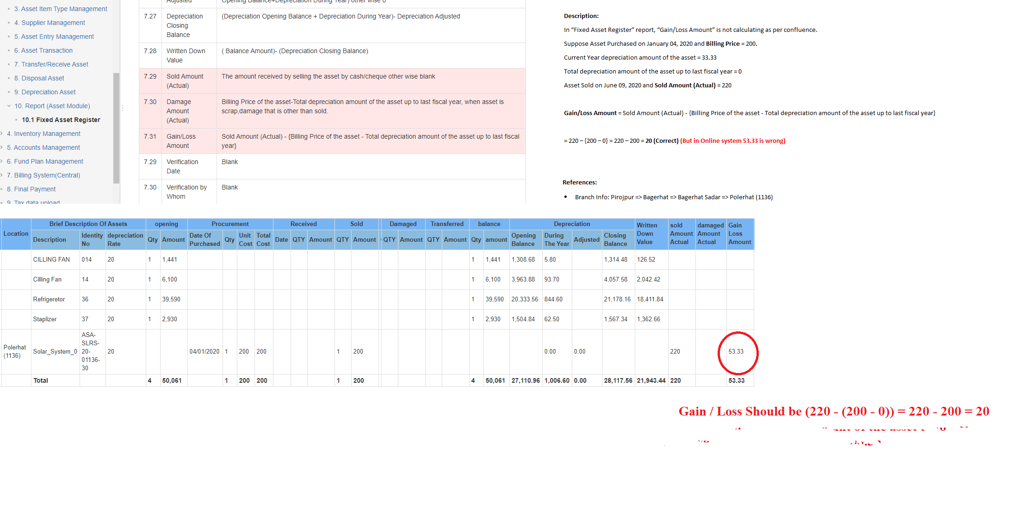

- Title: (Closed) Talked to Asif and make him understood.
In “Fixed Asset Register” report, “Depreciation Opening Balance” in Online system mismatched with Branch System.

Description:
Suppose Asset Purchased on January 04, 2020 and Billing Price = 200 Where Branch Working day is June 09, 2020.
Run on “On Demand Depreciation” on Branch Working day e.g. June 09,2020. That means here 5 depreciation rows will be inserted.

Asset Id | Transaction Date | Branch Working Day | Depreciation Amount | Depreciation Period
1 | June 09, 2020 | June 09, 2020 | 6.67 | 01312020
1 | June 09, 2020 | June 09, 2020 | 6.67 | 02282020
1 | June 09, 2020 | June 09, 2020 | 6.67 | 03312020
1 | June 09, 2020 | June 09, 2020 | 6.67 | 04302020
1 | June 09, 2020 | June 09, 2020 | 6.67 | 05312020

- If you take “Transaction Date” into consideration then for the month of February, 2020

Asset Id | Depreciation Opening Balance | Depreciation During | Depreciation Adjusted | Depreciation Closing Balance
1 | 0 | 33.35 | 0 | 33.35

- If you take “Depreciation Period” into consideration then for the month of February, 2020

Asset Id | Depreciation Opening Balance | Depreciation During | Depreciation Adjusted | Depreciation Closing Balance
1 | 6.67 | 26.68 | 0 | 33.35

References:
- Branch Info: Pirojpur => Bagerhat => Bagerhat Sadar => Polerhat (1136)

- Title: (Closed) Reported in Jira AMMSW-2596
In “Inventory Register” report, purchased Inventory is showing in both “Opening” and “Procurement” column if the purchased date is selected as “From Date”.

Description:
An inventory under “IT Non-Asset” category was purchase on February 02, 2020.
In “Inventory Register” report, “From Date” is selected February 02, 2020 which is purchased date and “To Date” is selected June 09, 2020.
Then in the report that inventory item should show only in “Procurement” column. But that inventory item is showing in “Opening” column also which should not be.

References:
- Branch Info: Pirojpur => Bagerhat => Bagerhat Sadar => Polerhat (1136)

Screenshot:
Please see details in screenshot
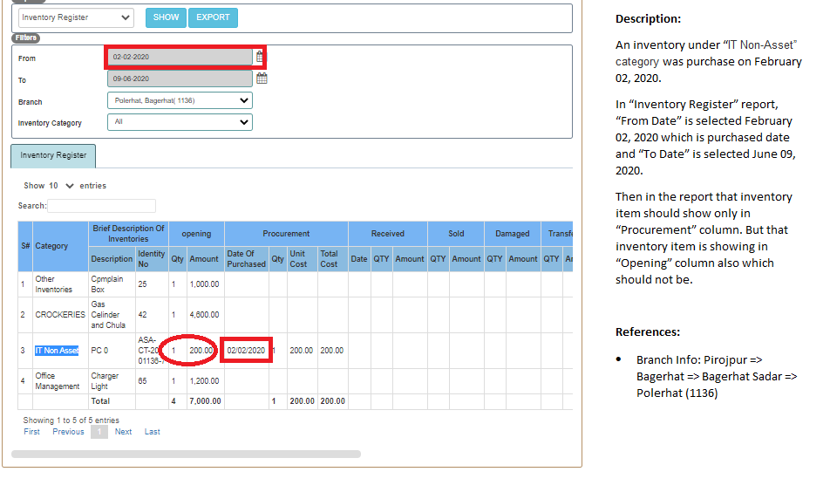

Follow Fixed Asset Register which is correct.
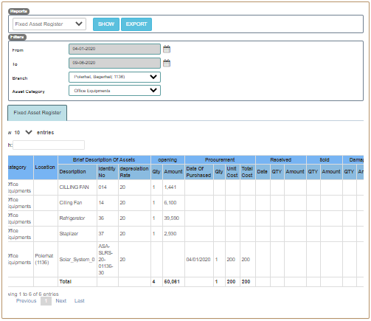

So far Reported Report issues: AMMSW-2541, AMMSW-2542, AMMSW-2543, AMMSW-2544, AMMSW-2556, AMMSW-2564, AMMSW-2592, AMMSW-2593, AMMSW-2596

